2007 Third Professional Year Project

Report Guidelines

Steven M. Durbin & Peter J. Smith

Supervisor: Andrei Kolmogorov
Abstract

This document provides a template and guidelines for students preparing final project reports for ENEL 427, Third Professional Year Project. Instructions within this document should be adhered to closely. Excluding title page, abstract page, references and any appendices, the maximum page limit is 15 pages. This limit may not be exceeded. Appendices are for additional background material and are NOT to be used as a place to extend the report and avoid the page limit. A penalty schedule applies for reports which do not fall within the guidelines as presented in this paper.

The datalogger built is capable of measuring voltage signals in the range of -60V to +60V and can measure the temperature using a direct connection to themocouples. With the use of transducer interface circuits,

INTRODUCTION

The aim of this project is to design and build a multiple channel datalogger. Dataloggers have many applications and can be used to establish relationships between several variables or to map trends in environmental conditions.

Dataloggers tend to measure signals which vary slowly over time, which have time constants in the order of seconds to minutes. This is in contrast to a data acquisition system whose sampling rates are in the order of several hundred kilo-samples per second. Dataloggers are suited to measuring temperature for example, where sampling at a high rate would be misleading because of the thermal time constants associated with the temperature sensor.

Although fundamentally limited to measuring voltages, dataloggers can measure a vast range of environment variables through the use of transducers. The two main types of transducers are passive and active. Passive transducers require some sort of electrical excitation to produce an output, whereas active transducers do not. Examples of passive transducers are thermistors and resistor temperature detectors (RTDs). A thermocouple produces its own voltage potential and is an example of an active transducer [See Britanica].

The majority of transducers output very small signals or variations and cannot be directly measured with digital equipment. The signals needs to be amplified and conditioned to maximise noise rejection before being read by an analogue to digital converter (ADC). For example a K-type thermocouple produces only 40μV per degree Celsius; this requires a low noise amplifier to increase the signal before it may be read by an ADC.

Dataloggers usually run off batteries and need to have very low battery power consumption. It is not uncommon for dataloggers to be left unattended capturing data for days or weeks on end. The medium on which the data is stored as well as how the data is retrieved are other major design considerations.

Issues facing dataloggers today are, low battery consumption, high accuracy and resolution, fast sampling rates and efficient methods of data storage and retrieval.

[Show system]

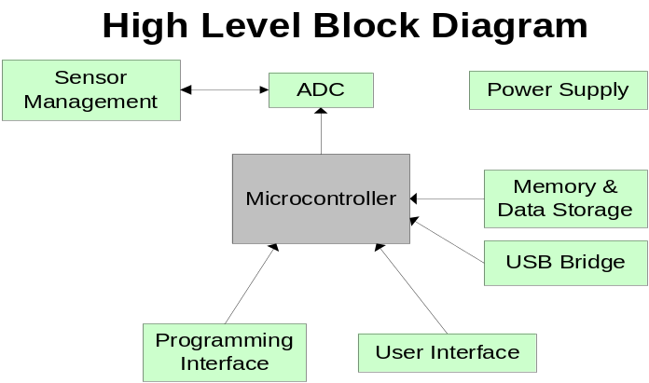

Figure 1. High level block diagram of the datalogger.

PROJECT MANAGEMENT
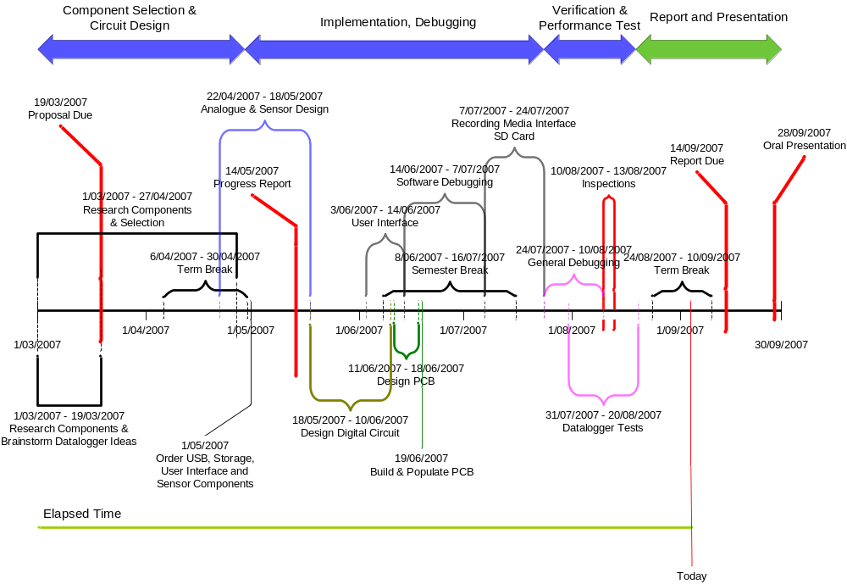
Figure 2. Project Timeline

HARDWARE DESIGN

The three major components of the datalogger are the sensors, user-interface and data storage circuitry.

Sensor Input Design

Voltages from K type thermocouples will be the smallest signal that this datalogger will be designed to measure. K-type thermocouples output approximately 40μV per degree Celsius and have a very high output impedance []. To measure such small voltages accurately, it is important that the voltage source is not heavily loaded and that the signal is resistant to electrical noise.

Each input channel is physically configured for either voltages or thermocouple inputs. The only difference is that a resistor divider network is loaded on the voltage inputs. Although this reduces the signal to noise ratio (SNR), it allows voltages up to ±60V to be measured. Therefore caution must be taken not to allow more than 5V common mode voltage between the thermocouple inputs.

A modular sensor input front-end allows up to eight sensor cards to be connected. Each sensor card provides four differential channels. With all eight sensor slots utilised, up to 32 fully differential channels can be used to record data from. Each channel is multiplexed into the differential amplifier and subsequent signal conditioning circuitry.

Signal Conditioning

The primary input gain stage was comprised of three op-amps connected in an instrumentation amplifier configuration. This configuration was chosen because it has very high input impedance and common-mode rejection []. These two factors allow voltage signals from thermocouples to be amplified accurately and subsequently read by an analogue to digital converter (ADC).

Voltages being placed at a sensor input will most likely need to be reduced or amplified before being passed to the ADC. Having variable gain is one way to condition the signal thereby utilising the maximum input range of the ADC [,]. Variable gain is achieved by switched resistor networks in place of the gain resistors in the instrumentation amplifier. Ten different gain settings have been calibrated which provide gains ranging from 0.04 to 270 V/V.

By oversampling the signal, a lower order analogue anti-aliasing filter can be used, thereby reducing costs and circuit complexity. Noise is also reduced, increasing the resolution of the analogue to digital conversion [].

A 22-bit Sigma Delta (ΣΔ) Burr-Brown ADC (ADS1213) was used to digitise the analogue signals. Data is read out of the ADC serially into the main microcontroller. The maximum output data rate of the ADS1213 was configured to 12.5 kHz. An oversampling factor of 12.5 meant that frequencies up to around 1 kHz could be accurately recorded. By oversampling, the Nyquist-Shannon theorem is satisfied, this states that the sampling rate needs to be at least twice that of the largest frequency of interest [Error: Reference source not found].

An active voltage controlled voltage source (VCVS) 2nd order low pass Bessel anti-aliasing filter was built to reduce the noise and increase the resolution of the AD conversion. The Bessel polynomial was chosen for its linear phase response []. The cutoff frequency was designed for 1 kHz to introduce an oversampling factor of 12.5. Since the oversampling technique was employed, a simple 2nd order filter was sufficient.

Memory and Data Storage Design

Major considerations when determining the medium on which data is stored include, price, access (read and write) times, physical size, power consumption and data capacity. Secure Digital (SD) Card was the chosen medium over other recordable media such as compact flash (CF), floppy disk and hard disk drive. This was because SD cards have reduced physical size, power consumption and pin count over other types.

Despite Electrically Erasable Programmable Read Only Memory (EEPROM) being relatively easy to interface with, SD Cards are more cost effective, have faster write times and higher write cycle endurance []. Provision was made however for writing to an EEPROM IC because of the significant cost of an SD Card.

Data may be recorded on either an external EEPROM IC or SD Card. Logged data may then be retrieved via the USB connection or by removing the SD Card and placing it into an SD Card reader connected to a PC.

User and Communications Interface Design

A keypad and an LCD display allow the user to adjust various datalogger settings. These include the ability to adjust sampling rate and channel status (on/off, voltage/temperature). A detailed listing of the datalogger menu can be found in Appendix X.

The datalogger can connect to a PC via a Universal Serial Bus (USB) connection. A USB was chosen over a standard RS-232 connection because of increased speed and increased availability of USB ports among modern PCs [, ].

The primary use of this connection is to allow the user to download recorded datasets. Data is transferred at a maximum rate of 1 megabit (Mbit) meaning a 10 megabyte dataset can be downloaded in 80 seconds. This connection also provides various hardware commands and diagnostics to determine any hardware faults.

Microcontroller

Four different brands of microcontrollers were studied, these were: Microchip’s dsPIC and PIC18F series, ARM based, Texas Instruments MSP430 series and Atmel’s AVR line. These devices were all capable of performing the required functions, and the selection was based upon the device whose software could be developed quickest and most efficient. Table 1 shows a brief comparison among the devices.

MicroController | Advantages | Disadvantages
dsPIC; PIC18F | On board DSP unit | Limited software building utilities
ARM | High speed | High power consumption
MSP430 | Low Power consumption
AVR | Good software building tools  Familiarity with devices
Table 1. Advantages and Disadvantages among different microcontrollers

An ATMEGA32L was chosen as the microcontroller based on the familiarity with the AVR series and the accompanying software building tools.
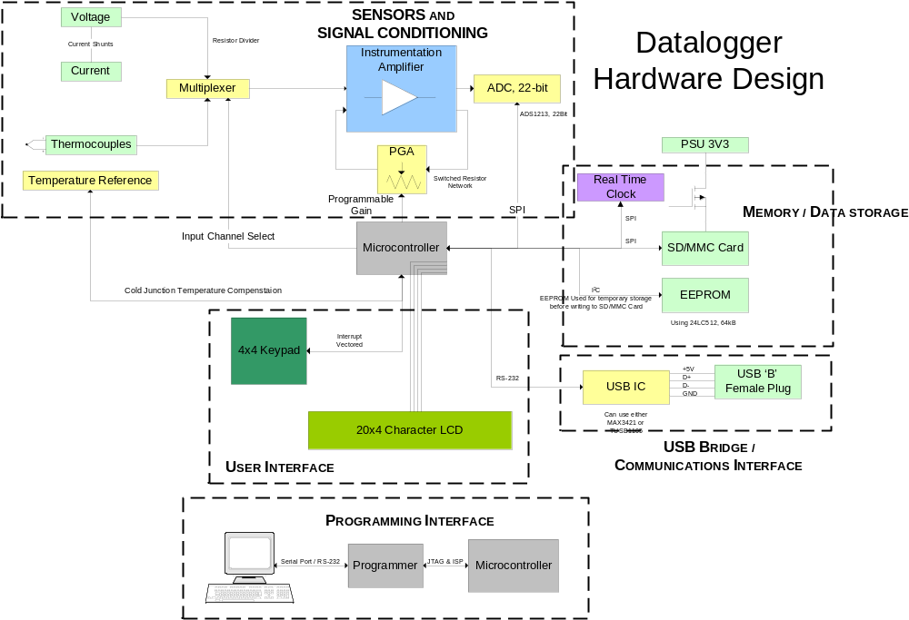
Figure 3. Datalogger Hardware Design

SOFTWARE DESIGN

Software was designed with continual development in mind. This meant that software development processes needed to be used. Automated document and source control are such processes which were employed to aid future development.

‘Doxygen’ provided a way to keep track of documentation and could also present each software module in a PDF or HTML document. This would display the comments and usage associated with each function and variable, thus helping developers understand the code.

‘Subversion’ (SVN) was used to keep a working and updated copy of the code. Subversion works by having a ‘code repository’ which is continually updated and backed-up after each code revision. This allows code to be reverted to an older, previous revision if the current version becomes unstable with bugs. The code repository is located at: http://avr-datalogger.googlecode.com/svn/.

C was the preferred programming language as a software tool-chain, WinAVR, provided all the essential programming tools to program the ATMEGA32 in C. This included a C compiler, linker and a ‘make’ script. C language was preferred over assembler as it allows the development of efficient programs in low-level systems [].

SVN and Doxygen and other programs in the WinAVR tool-chain automated key aspects of the software design process. This would help future developers understand and improve on the existing code base as well as reduce the possibility of buggy software [,].

To aid software design, a dataflow diagram (Figure 4) was produced before any coding had begun. The red lines represent the flow of data, the boxes represent modular routines and the circles represent control modules. To simplify implementation, the software was partitioned into sensor control, data storage and user interface routines.

A modular design was aimed for as this would simplify implementation as well as allow portions to be reused in another application. An abstract design meant that the code could be ported to any type of processor that has supporting C programming tools. In the long term, these design features would allow the software to be maintained and possibly improved by other developers [].

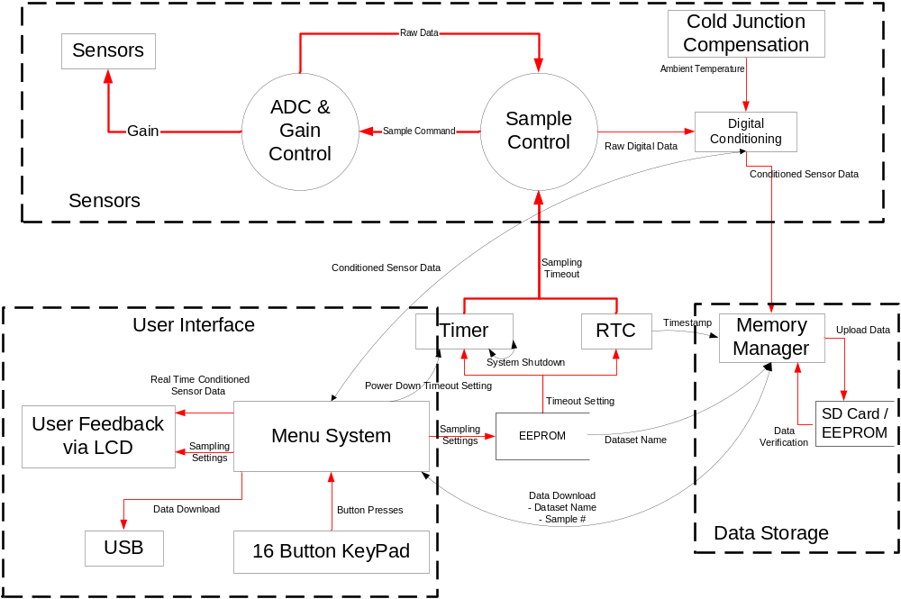

Figure 4. Software Dataflow Diagram for the Datalogger

DISCUSSION

A test case () was set up with a variable DC voltage supply providing current to an 11Ω and 1Ω resistor. A thermocouple was placed onto the heatsink of the 11Ω to measure its temperature.

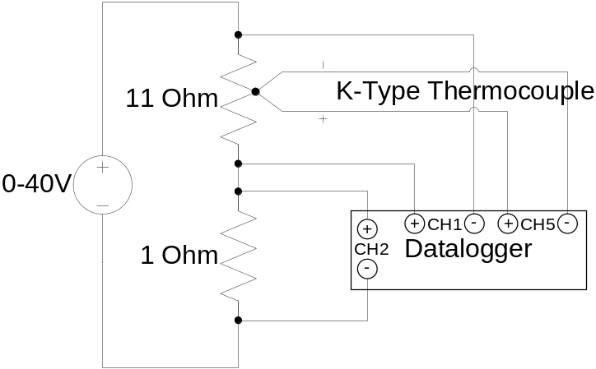

Figure 5. Datalogger test case setup

Approximately 30 seconds of data was captured and the relationship between each variable was plotted in Figure 6. When the voltage across the resistor is 32.5V, current through the 11 Ω can be calculated to be 2.96A. This value corresponds to that recorded by the datalogger as shown in Figure 6. The temperature of the resistor can also be seen to increase linearly with energy input. A steady state temperature will be reached when the heat transfer by radiation and convection equal that of the input power.

This datalogger allows relationships between different variables to be established. One application is that it be used for testing and analytical purposes. Several variables could be logged, and once profiled, may provide an insight into how they are related. The measurement of voltage, current and temperature of an 11Ω resistor is one example.

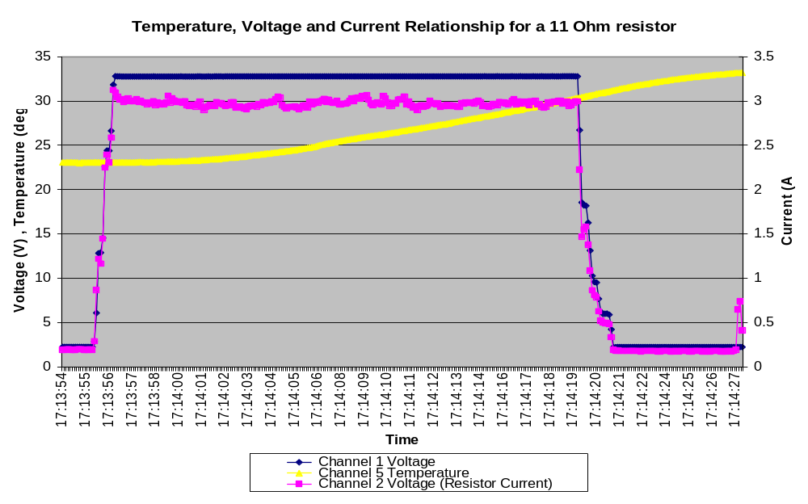
Figure 6. Voltage, current and temperature relationship for an 11Ω resistor

In the example above, xxx samples were taken over xx seconds. The maximum sampling rate is xx milliseconds. Therefore only signals with a frequency component of xxHz can be logged precisely. Increasing the number of channels being logged may also limit the maximum sampling rate for each channel. Thus this datalogger is most suited to measuring steady-state variables.

Improvements

The central microcontroller used was an 8-bit ATMEGA32 operating at 8 MHz. More features and functionality could have been implemented had a Texas Instruments MSP430 microcontroller been used. The MSP430x2xx family are 16-bit processors which may operate up to 16MHz, their power consumption is also much lower than that of an ATMEGA32 [].

Currently, sampling rates are limited by the microcontroller, not the ADC. By using a faster microcontroller, faster sampling rates can be achieved thereby allowing data containing high frequency components to be logged. However there is a trade off between performance and power-consumption.

It would be useful to have a real-time fast fourier transform (FFT) to display the frequency composition the input signals. However it was decided that a poor real-time FFT performance would result due to the memory and speed limitations of an ATMEGA32 and the complexity of calculating an FFT [].

A future design should solely use surface mount components. Some through hole parts were used due to a longer than expected lead time for surface mount components. This change increased the physical size of the board and hence increased production costs.

Other design considerations

4. CONCLUSIONS

APPENDIX (OR APPENDICES)

Appendices may include tables of data, source code, procedures or other information suggested or required by the project supervisor. Its presence will be noted by the examiners, but the content will not be graded.

[?] R. Mancini, “Op Amps for Everyone” Design Reference: SLOD600B, Texas Instruments, 2002, pp. 12-1 – 12-23
[?] D. L. Terrell, “Op Amps: Design, Application and Troubleshooting”, 2nd Ed, Butterworth-Heinemann, 1996, pp 405-409
[?] B. A. Gregory “An Introduction to Electrical Instrumentation and Measurement Systems”, 2nd Ed, The MacMillan Press, 1981. pp 276-278
[?] R. Mancini, “Sensor to ADC – Analog Interface Design”, SLYT015, Texas Instruments, 2000
[?] S. Tumanski, “Principles of Electrical Measurement”, Taylor and Francis, 2006, pp 211
[?] D. E. Johnson, “Introduction to Filter Theory”, Prentice-Hall Inc, 1976, pp 147-154
[?] Datalight Inc. “NAND vs. NOR flash”, http://www.windowsfordevices.com/articles/AT6841560808.html, accessed 5 September 2007.
[?] L.D de Almeida Pereira Zuquim, C.J.N Coelho Jr., A.O. Fernandes, M.P de Oliveira, A.I.Tavares, “An embedded converter from RS232 to Universal Serial Bus”, IEEE Integrated Circuits and Systems Design, 2001, 14th Symposium on.10-15 Sept. 2001 pp 91-96.
[?] J. Axelson, “USB Complete”, 2nd Ed, Lakeview Research, 2001. pp 1-20
[?] I. Sommerville, “Software Engineering”, 6th Ed, Addison-Wesley, 2001, pp 289-305
[?] A. Bainbridge-Smith, “Version Control”, University of Canterbury, ENEL428 Lecture Notes, 2007.
[?] A. Bainbridge-Smith, “Building Software”, University of Canterbury, ENEL428 Lecture Notes, 2007.
[?] D. Budgen, “Software Design”, 2nd Ed, Addison-Wesley, 2003, pp 63-85.
[?]Texas Instruments, “MSP430x2xx Family” User Guide: SLAU144C, Texas Instruments, 2007, pp. 1-6
[?] M. Frigo and S. G. Johnson, "The Design and Implementation of FFTW3," Proceedings of the IEEE 93 (2), 2005, pp 216–231. http://www.fftw.org/

